Experiment No. 4
SE (CSE) ROLL NO : 10937
Date of Implementation: 26-02-2026
Aim: Implement simple linear regression for the given data set
Programming Language Used : Python
Upon completion of this experiment, students will be able to CO3 : Perform prediction by applying regression models
 | Indicator |  | Poor |  | Average | Good
 | Timeline  Maintains submission deadline (2) |  | Submission not done (0) |  | One or More than One week late (1) | Maintains deadline (2)
 | Completion and Organization (2) |  | Many mistakes in documents (0) |  | Document is just acceptable (1) | Completed whole document and neatly organized (2)
 | Program Performance (2) |  | Could not perform at all (0) |  | Implemented few parts (1) | Full implementation (2)
 | Knowledge  In depth knowledge of the Experiment (4) |  | Unable to answer questions(0) |  | Unable to answer few questions (1-2) | Able to answer all questions with proper explanation (3-4)
Assessment Marks :
 | Timeline
 | Completion and Organization
 | Program Performance
 | Knowledge
TOTAL :

EXPERIMENT | 4
Aim | Implement simple linear regression for the given data set
Theory | Simple linear regression is used to estimate the relationship between two quantitative variables. You can use simple linear regression when you want to know:  - How strong the relationship is between two variables (e.g., the relationship between rainfall and soil erosion).  - The value of the dependent variable at a certain value of the independent variable (e.g., the amount of soil erosion at a certain level of rainfall).  Regression models describe the relationship between variables by fitting a line to the observed data. Linear regression models use a straight line, while logistic and nonlinear regression models use a curved line. Regression allows you to estimate how a dependent variable change as the independent variable(s) change.  Simple linear regression is a parametric test, meaning that it makes certain assumptions about the data. These assumptions are: Homogeneity of variance, Independence of observations, data follows a normal distribution and relationship between the independent and dependent variable is linear.
Implementation | - Perform the given task in python Consider the following data  - Print first 5 rows of data  - Display scatter plot of data  - Calculate (using formula) and print regression coefficients b0 and b1  - Display regression line equation  - Calculate and print coefficient of determination (R squared,  Residual sum of squares (RSS), and RMSE  - Plot regression line  - Predict the value of y given x=10  - Perform the following task using inbuilt functions in python  - Import the packages numpy, pandas and the sklearn.linear_model  - Read data set (advertising.csv)  - Select the column ‘TV’ as independent variable and ‘sales’ as dependent variable  - Divide data into training and testing split  - Create an instance of the class LinearRegression, which will represent the regression model  - Fit the model for training data  - Get coefficients of regression and coefficient of determination from the model  - Apply the model for predictions on testing data.
X | 0 | 1 | 2 | 3 | 4 | 5 | 6 | 7 | 8 | 9
y | 1 | 3 | 2 | 5 | 7 | 8 | 8 | 9 | 10 | 12

 | i) Show the residual error plot for training (with green color dots), testing data (blue color) and zero residual error line
Conclusion | Comment on the predicted output and the corresponding error value obtained. Additionally, compare the regression coefficients calculated manually with those computed using built-in functions
Post Lab Questions: | - Explain standard error of coefficients  - Explain coefficient of correlation, coefficient of determination

Code & Output:

Manual Implementation:
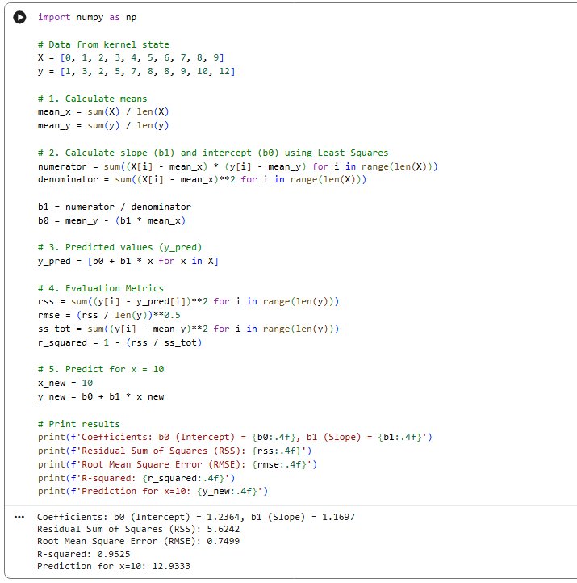

Implementation on `Advertising.csv` using Built-in Functions:
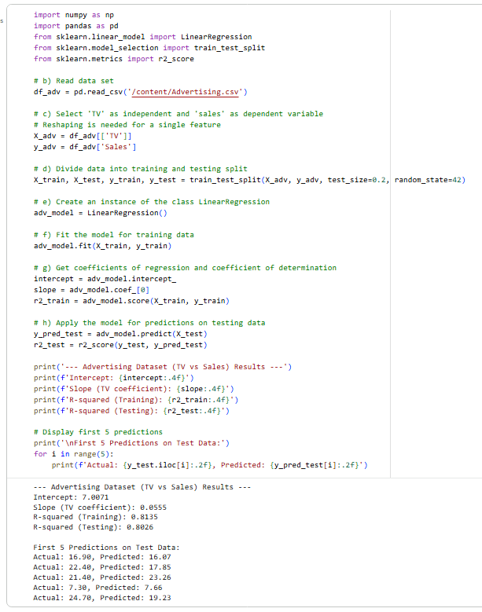

Visualization on ScatterPlot: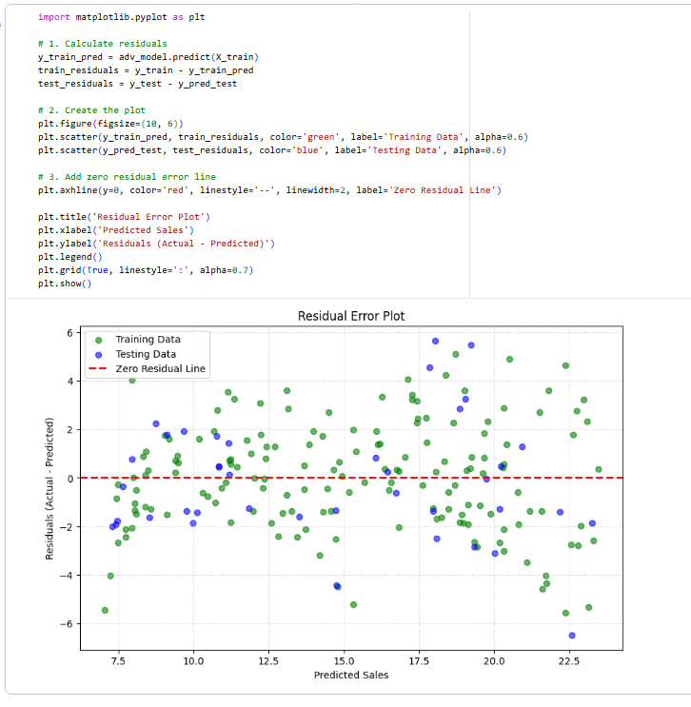

Post Lab Questions:
- Explain standard error of coefficients
Sol. The Standard Error (SE) of a regression coefficient estimate is a measure of the precision of the estimate.

- Explain coefficient of correlation, coefficient of determination.
Sol. i) Coefficient of Correlation tell the linear link between the variables.
ii) Coefficient of Determination is denoted by R². It tells us how well the regression model fits the data.

Conclusion:
The linear regression model works well and captures the trend of the data. The predicted value for (x=10) (12.9333) logically continues the observed trend. The error values are low (RMSE = 0.7499, RSS = 5.6242), and the (R²) value is high (0.9525), which is a good fit with very little deviation. The consistency of the results obtained from manual calculations and scikit-learn verifies the correctness of the code.

